CMPG 325 milestone 2: client implementation review
AUTHOR: NASIPHI MLAMBO 41555597

Contents
1.Project overview 1
2. Network Design summary 1
2.1 Physical Topology 1
2.2 logical topology(VLANs) 1
2.3 IP Addressing Plan 1
3. Implementation details 2
3.1 Router configuration(R1-Tlhogo) 2
3.2 Switch configuration 2
3.3 Port Security(Assigned Challenge) 2
3.3.1 Reason for Port Security 2
4. Testing evidence 3
4.1 Test 1: PC-Admin – Gateway 3
4.2 Test 2: PC-Admin – pc-projects 3
4.3 Test 3: PC-Admin-PC-Finance 3
4.4 Test 4: Port Security-Sticky MAC Learned 4
4.5 Test 5: Port Security-Violation Triggered 4
5. Troubleshooting 5
6. Change Request CR5 — 25% Growth 5

1.Project overview
Client: Tlhogo Roofing & Construction (Vryburg)
Client ID: CLI-074
Industry: Construction
Assigned Challenge: Port Security (switchport access control)
Addressing Block: 192.168.37.0/24

2. Network Design summary

2.1 Physical Topology
- 1 × Router 2911 (R1-Tlhogo) — Inter-VLAN routing and gateway
- 4 × Switch 2960 (SW-Core, SW-Admin, SW-Projects, SW-Finance)
- 3 × PC (PC-Admin, PC-Projects, PC-Finance)

2.2 logical topology(VLANs)
VLAN ID | Department | Subnet | Gateway | Usable IPs
10 | Admin | 192.168.37.0/27 | 192.168.37.1 | 30
20 | Projects | 192.168.37.32/27 | 192.168.37.33 | 30
30 | Finance | 192.168.37.64/28 | 192.168.37.65 | 14

2.3 IP Addressing Plan
DEVICE | IP ADDRESS | SUBNET MASK | GATEWAY
PC-Admin | 192.168.37.2 | 255.255.255.224 | 192.168.37.1
PC-Projects | 192.168.37.34 | 255.255.255.224 | 192.168.37.33
PC-Finance | 192.168.37.66 | 255.255.255.240 | 192.168.37.65

3. Implementation details

3.1 Router configuration(R1-Tlhogo)
Sub-interfaces were created for Router-on-a-Stick configuration:
interface GigabitEthernet0/0.10
encapsulation dot1Q 10
ip address 192.168.37.1 255.255.255.224

interface GigabitEthernet0/0.20
encapsulation dot1Q 20
ip address 192.168.37.33 255.255.255.224

interface GigabitEthernet0/0.30
encapsulation dot1Q 30
ip address 192.168.37.65 255.255.255.240

3.2 Switch configuration
VLANs created: 10 (Admin), 20 (Projects), 30 (Finance)
Trunk ports configured: SW-Core to router, SW-Core to access switches, SW-Finance to SW-Core
Access ports configured: Each PC assigned to its correct VLAN

3.3 Port Security(Assigned Challenge)
Configured on SW-Admin Fa0/2 (the port connecting to PC-Admin):
interface fa0/2
switchport mode access
switchport port-security
switchport port-security maximum 1
switchport port-security violation restrict
switchport port-security mac-address sticky

3.3.1 Reason for Port Security
The client constraint states: "Customer records are confidential — access must be controlled."

Port Security prevents unauthorized devices from connecting to the network by locking each switch port to a specific MAC address.

4. Testing evidence

4.1 Test 1: PC-Admin – Gateway
ping 192.168.37.1
result: 0% loss
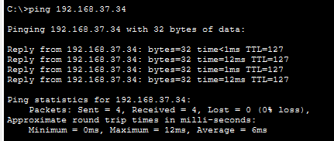

4.2 Test 2: PC-Admin – pc-projects
ping 192.168.37.34
result: 0% loss
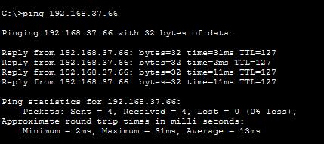

4.3 Test 3: PC-Admin-PC-Finance
ping 192.168.37.66
result: 0% loss
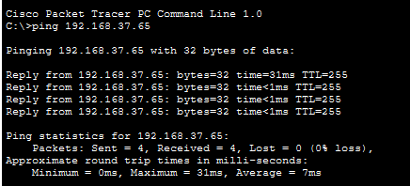

4.4 Test 4: Port Security-Sticky MAC Learned
show port-security address
Result: PC-Admin's MAC address locked to Fa0/2
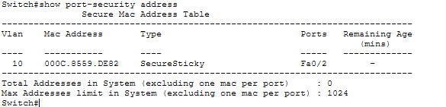

4.5 Test 5: Port Security-Violation Triggered
A rogue PC was connected to Fa0/2. Its traffic was blocked:
- show port-security interface fa0/2
result: Security Violation Count : 6

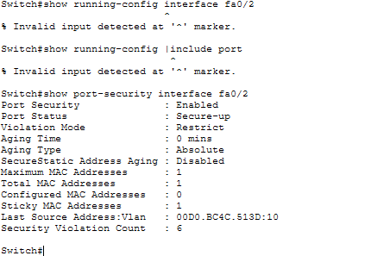

5. Troubleshooting

ISSUE | CAUSE | RESOLUTION
Packet loss on VLAN 20 | Unused port Fa0/4 flapping in auto mode | Shut down Fa0/4
VLAN 30 unreachable | ARP not resolving | Restarted sub-interface and switches; rebuilt topology
STP blocking on trunk | Native VLAN mismatch after port changes | Reconfigured native VLAN 1 on both ends

6. Change Request CR5 — 25% Growth
The addressing plan uses VLSM with the following reserved growth room:
VLAN | CURRENT NEED | SUBNET SIZE | AVAILABLE | GROWTH ROOM
10 | 24 Users | /27 (30 hosts) | 30 | 25%
20 | 24 Users | /27 (30 hosts) | 30 | 25%
30 | 10 Users | /28 (14 hosts) | 14 | 40%

Additional growth space: 192.168.37.160 – 192.168.37.255 (96 addresses) reserved for future VLANs.

